
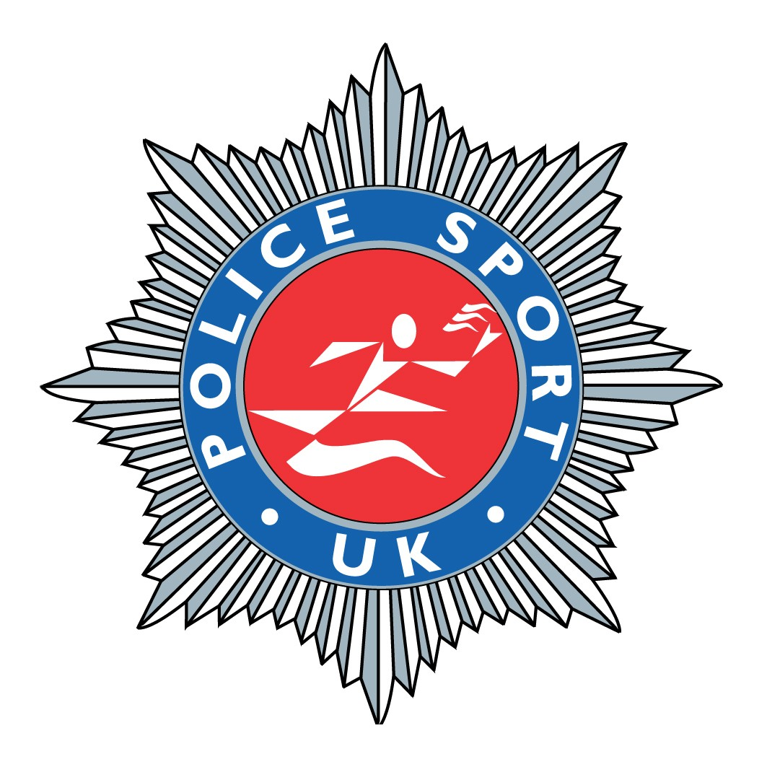
Police Sport UK Entry Form

NB: Form fill document - Use ‘Tab’ key to move from field to field
Force:
Name: Title First Name Last Name
Police Title/Post:
Address:

Post Code:
Date of Birth: / / Age on Race Day: Gender:
Telephone: Mobile Work
Email:
‘T’ Shirt Size:
Predicted Time:
Payment
Edinburgh Marathon Entry:
Police Sport UK Championship Entry: £15.00
Total Payment:

Please make all cheques payable to: “LCSSC”.
Return to: SC Steven Broadbent, Carnforth Police Station, Grosvenor Road, Carnforth, LA5 9DQ.

Disclaimer:
I declare I will be 18 years or over on the day of the event and will abide by the laws and rules of the Scottish Athletics Limited (SAL). I declare that I will not compete in the race unless I am medically fit on the day of the race and that, in any event, I will compete at my own risk. I accept that the organisers /sponsors /partners / marshals will not be liable for any loss, damage, action, claim, costs or expenses, which may arise in consequence of my participation of the event. I also hereby give my permission to Edinburgh Marathon Ltd to use my name, quotes and photographic likeness for marketing and promotional purposes. I also understand that entry fees are non refundable.
I agree to the above disclaimer
Receive eNewsletter - full with training advice and up to date news. (You can opt out at any time)
I don't mind you sharing my information with parties connected to Edinburgh Marathon.

