
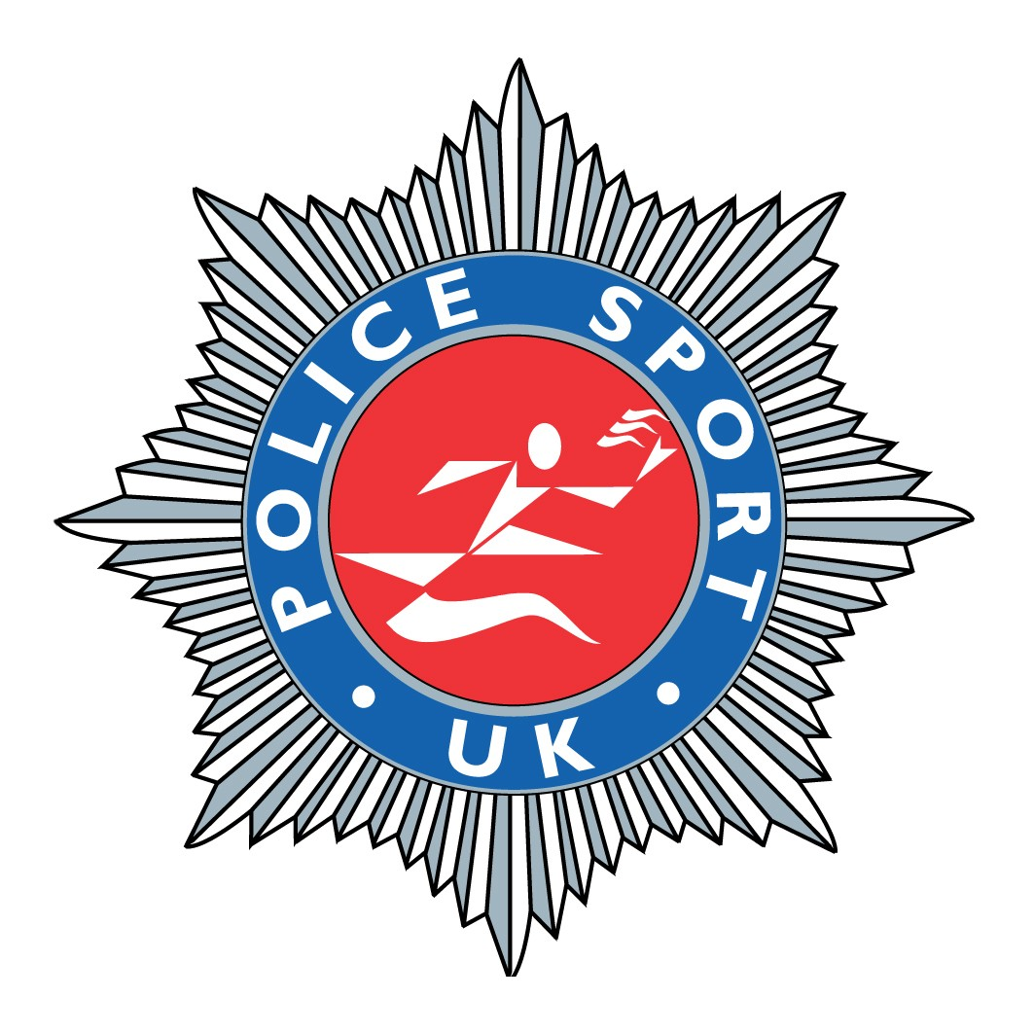
SC Steven Broadbent
Carnforth Police Station
Grosvenor Road
Carnforth
LA5 9DQ

Work Tel: 01524 596424
Home Tel: 01539 824654
Mobile: 07974795466
Fax: 01524 596446
E.Mail: steve@policesport.net

Dear Colleague

Police Sport UK Marathon Championships 2008

The 2008 Police Sport UK Marathon Championships will take place in Edinburgh on Sunday 25 May 2008 incorporated within the official Edinburgh Marathon event.

Police Race HQ and Presentation Venue

A contact point will be set-up at the Premier Travel Inn, Carberry Road, Inveresk, Musselburgh EH21 8PT on Saturday 24 May 2008 between 6pm and 10pm.

A formal Police Sport UK presentation and buffet will be held at the Craig House Restaurant at approximately 2.30pm on Sunday 25th. This venue is located next door to the Premier Travel Inn.

Accommodation

The official event hotel is the Premier Travel Inn, Inveresk where we have only been able to secure 11 twin rooms for Saturday 24th and Sunday 25th May at a cost of £56 per room per night. Contact me by email if you wish to reserve a room. This will be on a first come, first served basis to those stopping both nights.

Therefore any remaining competitors need to make their own arrangements regarding accommodation. There are many excellent hotels in and around the City to suit all budgets.
Nirvana Europe Ltd the official event travel agent for the Edinburgh Marathon, can provide you with any combination of services including accommodation, travel and tours.
Tel: 0191 293 6592 - Fax: 01912936593 - E-Mail: mail@nirvanaeurope.com - Web: nirvanaeurope.com

Post Race Shower and Changing Facilities

I hope to secure a small number of courtesy rooms at the Premier Inn to be used to shower and change after the race and prior to the PSUK presentation taking place. The Premier Inn is only 1.6 miles from the marathon finish in Musselburgh and there is ample parking. Competitors could consider jogging back to the hotel from the finish to change. (See Appendix ‘A’ - Map 1)

Police Sport UK Entry

The Entry Fee for Police Sport UK. Championships will be £15.00. This fee covers the cost of the presentation buffet and the awards and prizes.

Edinburgh Marathon Entry

The Edinburgh Marathon fee costs £30.55. This is a special rate and includes a complete race entry package available to every competitor as well as results service.

Entry Form and Payment

A customised ‘Police Sport UK entry form’ accompanies this document as an attachment. Please complete an individual form for each competitor renaming each one respectively and return to me by email. Please forward your payment by post.

IMPORTANT: Please try and supply personal details including email address for each of your runners. This will mean that they will receive personal updates direct by email from the race organisers.

Course

The Edinburgh Marathon is now approaching its 4th year and again they expect a record number of entrants along with a record finishing time. The Edinburgh Marathon offers runners the ultimate personal challenge with a spectacularly scenic route, which takes runners past many of Edinburgh’s famous landmarks and tourist attractions.
The Edinburgh Marathon is more than just a race – it is a festival of fun with on-route entertainment and finish-line celebrations. The race day will also reflect great human spirit thanks to the thousands of runners raising much needed funds for charitable causes. (See Appendix ‘A’ - Maps 2, 3 and 4)
Entry Field
The event is expecting nearly 9,000 entrants to take part in the 2008 Edinburgh Marathon and the Team Relay.
Weather Conditions
May/June are probably the best months to run a marathon in Edinburgh. The wind is soft and the average maximum temperature on Race Day is around 17 degrees. (2005 provided soft rain and an average temperature of 13 degrees - June 2006 marathon was uncommonly hot with temperatures reaching 24°C, May 2007 was about 14 degrees and it should be between 15 and 17 degrees in 2008).
Champion Chip
Timings for all runners will be recorded using the Champion Chip system.
Prizes/Trophies

Police Sport UK Championships

Winners: Open Men, Open Women, Vet 40+ Men, Vet 50+ Men, Vet 35+ Women

Runner’s Up: Open Men, Open Women, Vet 40+ Men

3rd Place: Open Men, Vet 40+ Men

Teams: Winner and Runner’s Up - Men and Women Combined (First three to count)

Edinburgh Marathon Championships

See Edinburgh Marathon website for details

Qualification

Competitors must be 18 or over to run the marathon and all police competitors must be fully paid members of their respective force sports clubs and be police officer, police staff, retired police/police staff or member of the Special Constabulary. (If in doubt please refer to the www.policesportuk.com website for a detailed definition)

Competitors who have already entered the Edinburgh Marathon direct

Some police competitors may have already entered the marathon directly. If this is the case please specify this on the entry form. Only the £15 PSUK entry need be paid. I will liaise with the organisers and ensure the individual is re-entered as a PSUK entrant. Please note: The individual will not be eligible to compete as a team member for another non-police Club.

Closing Date

The closing date is strictly 2 May 2008 - this is set by the Edinburgh Marathon organisers. Late entries will not be accepted.

Entry Confirmation

Your runners will receive a confirmation of your entry by email/post.

Race Number and Chip Collection

The Edinburgh Marathon EXPO will be held in association with this spectacular event, in the stunning Ocean Terminal in Leith on Friday 23 May and Saturday 24 May.

The large-scale exhibition allows all runners and their family and friends to visit exhibition stands featuring various representatives from the sport, health and fitness industry. It also doubles as the registration venue for runners to pick up their race numbers and Champion Chips.

The Race and Race Course

The 2008 marathon route will start at 9am from Regent Road (just along from Princes Street). The route will follow most of the same route as the 2007 marathon following the Forth coastline through Portabello and Musselburgh before returning on a contra-flow part way, finishing in Musselburgh Racecourse Stadium.

See website for detailed course map and elevation profile.

Prizes and Presentation

A formal presentation and buffet will be held at the Premier Travel Inn, Carberry Road, Inveresk, Musselburgh EH21 8PT where the Police Sport UK prize presentation will take place in the adjoining Craig House Restaurant approximately 2.30pm.

Further Information and Results

Further information on the Edinburgh marathon, latest news and eventual results go to:

www.edinburgh-marathon.com

Our own dedicated web-page with information specific to the Police Sport UK Championships and final results go to:

www.policesport.org

Please do not hesitate to contact me if you have any further questions or require any other information.

I will await entries from you and your team and will look forward to seeing you in May.

Yours in sport,

Steve

SC Steve Broadbent
Police Sport UK Athletics Section - Marathon Co-ordinator

Work Tel: 01524 596424
Home Tel: 01539 824654
Mobile: 07974795466
Fax: 01524 596446
E.Mail: steve@policesport.net

Appendix ‘A’ - Various Maps

Map 1: Showing Marathon Finish and Police Sport UK Race HQ and Presentation Venue

1.6 miles from Marathon Finish to Premier Travel Inn
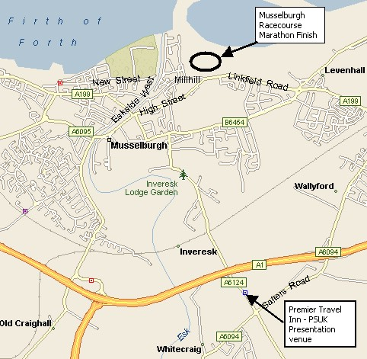

Map 2: Race Route Part 1
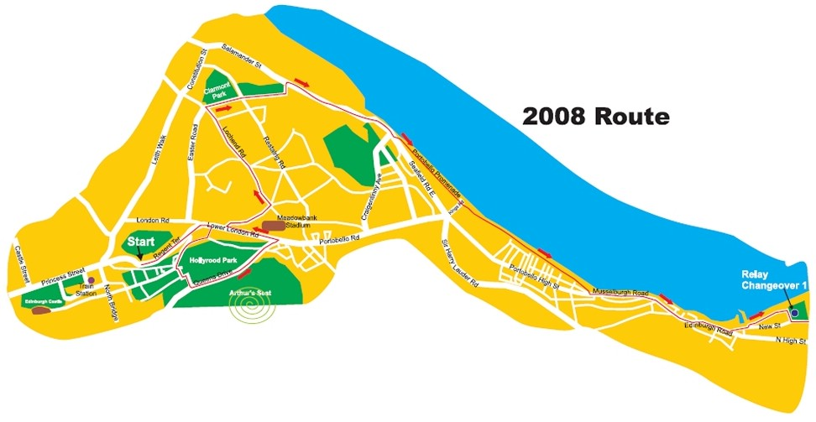

Map 3: Race Route Part 2

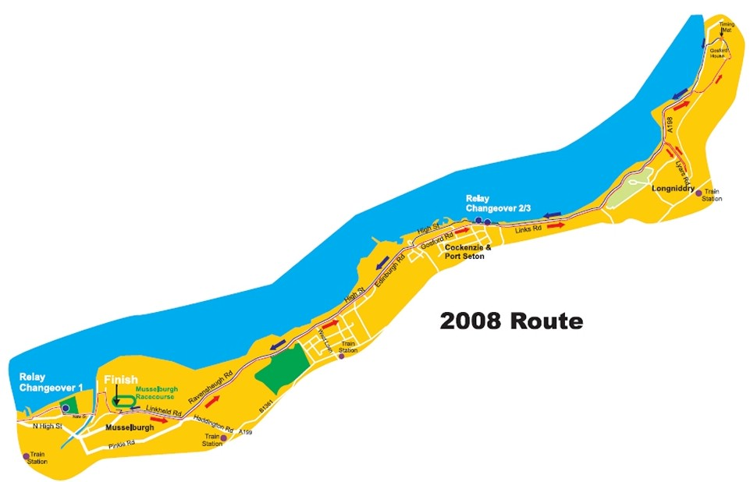

Map 4: Race Route Elevation

