Track & Field and Tug of War Championships 2011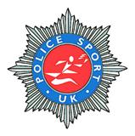

Solihull – West Midlands - Wednesday 6th July 2011

Advance Event Details

The 2011 Police Sport UK Track & Field and Tug of War Championships will take place at the Norman Green Stadium, Tudor Grange, Blossomfield Rd, Solihull, West Midlands. B91 1NB. The stadium is set within Tudor Grange Park.

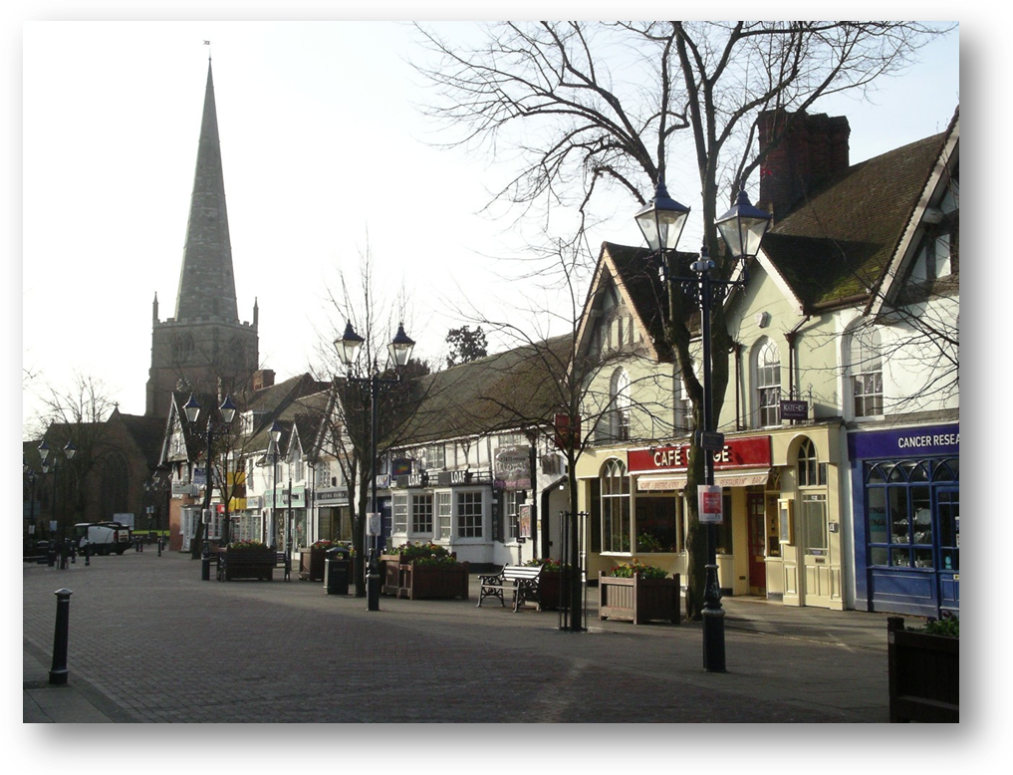

Solihull is a pleasant and affluent town 15 minutes drive south east of Birmingham. It is mostly residential, being served by a small town centre. Within the centre are the High Street shops including all the usual chain stores and a number of independent specialist retailers. The recently built Touchwood Centre has seen its popularity increase as a shopping destination, and it’s also home to a Cineworld Cinema, and many restaurants and bars. Solihull is also home to the world famous Land Rover brand.

Location:
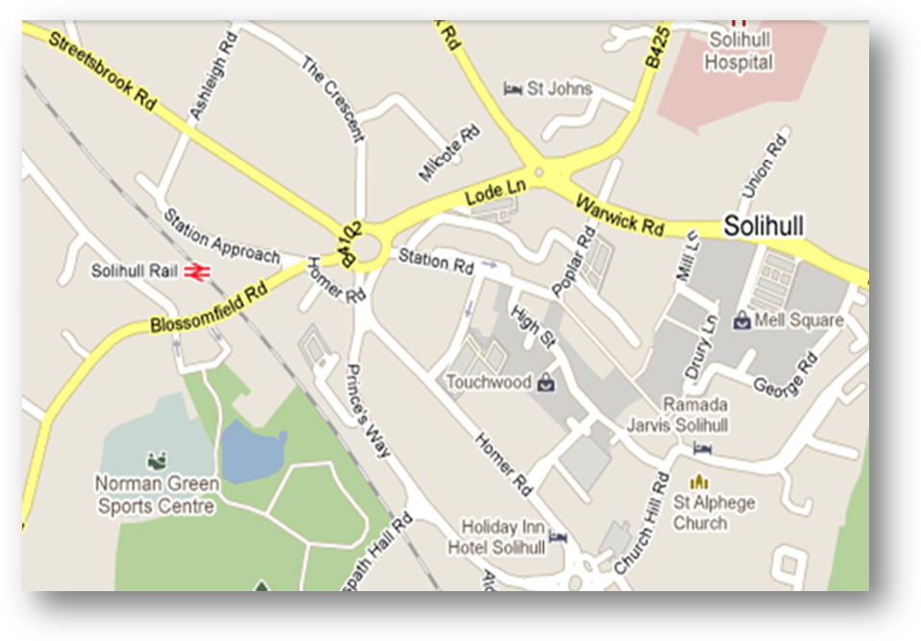

Accommodation

Rooms have been reserved at St John’s Hotel, Warwick Rd, Solihull, which is a 5 minute walk from the track. This will be the main hotel where we have negotiated a discount for members.
Cost per room per night is £65 for a twin.
Contact number 0121 711 3000.
There are a limited number on a first come first serve basis.
Quote PSUK on application.
A reception point will be set up here from 2pm until 10pm on Tuesday 5th July.

Other hotels are close by, including the Holiday Inn, and Ramada within Solihull town centre. Other hotels are slightly further out of town. Premier Inn have 3 hotels within 3 miles along Stratford Rd, Shirley, Solihull. Premier Inn Hockley Heath and NEC/Airport are also with 10 minutes drive away.
Holiday Inn, which is in Homer Rd, a 5 minute walk from the track, have also put aside a number of twin rooms at £129 per room until 27th May. Contact number 0871 942 9201, again quote PSUK.

Directions and Travel Arrangements

By Train: Norman Green Stadium is situated on the edge of Solihull town centre on the opposite side of the road to Solihull train stain station. Service to Solihull is from Birmingham Moor Street, or Birmingham Snow Hill, both in the city centre. If you are arriving via Birmingham New Street, then both stations are only a short walk away.

By Air: Solihull Town Centre is approx 7 miles from Birmingham International Airport. Arrangements can be made for pick up for teams arriving by air, with the event organisers, from Birmingham International Airport only.

By Road: Solihull is served by the M42 motorway, junction 5, with easy access from the M6, M5 and M40. Follow the A41 towards Solihull and take the first exit road off. Turn right onto Warwick Rd and into the town centre. At the next roundabout, (a) go straight over for St John’s hotel which is just on the right or (b) turn left and then take the 3rd exit at the next roundabout for Blossomfield rd. Just after the bridge is the entrance for Tudor Grange on the left, but take care, it’s easy to miss.

Stadium Access: Entry to the Stadium is gained by turning right as you enter the car park. By coming past the leisure on your left, keep going as far as you can and you will come to the car park for the track. There is a gate on the left as you enter the car park for access. At time of writing the council have decided to charge patrons for car parking as of March. Negotiations are taking place to waive this charge. More details will follow.
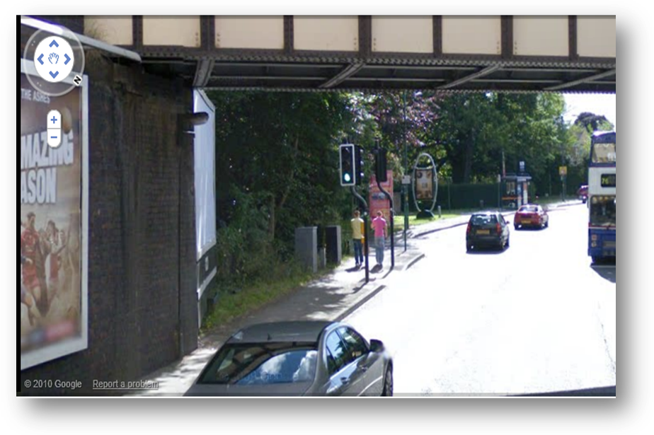
Just after the bridge is the entrance.
Blossomfield Road
Blossomfield Road

Police Sport UK Championships Entry

The entry fee will be £14 for each competitor’s first event. Any additional events will be £4 each. Team relay entries will be £15 for each team. Please see separate entry form for Tug of War. As per previous events £100 per team plus £15 per extra event.

All Cheques are to be made payable to “WMPSSC”

The entry form is attached with this document.

Please ensure that your competitors’ names are correctly spelt, as this is how they will appear on the programme.

Prizes/Trophies

We will give prizes to the first 3 in each Track & Field discipline, providing there are a minimum of 5 entrants. Below this number, prizes will be awarded to the first and second placed only. Prizes will go to the winners and runners up in the Tug of War.

All events will take place inside the stadium.

Athletes are required to register at the stadium at least 1 hour before their event.

Can you please all ensure the return of annual trophies, clean and engraved.

Presentations will take place shortly after the completion of the respective finals.

Qualification

Competitors must be 18 or over to compete. All police competitors must be fully paid members of their respective force sports clubs and be police officer, police staff, retired police/police staff or member of the Special Constabulary. (If in doubt please refer to the www.policesportuk.com website for a detailed definition). This event is for Police employees only.

Any number of competitors from any force may participate and there shall be no limit to the number of events a competitor may enter. In any relay event only one team from each force may win a prize.

All athletes must wear their force colours. Failure to do so will lead to disqualification.

Closing Date

The closing date will be 25th May. No late entries will be accepted. Entries are to be with me as per contact details on foot of this document. No entries on the day and no refunds for non attendance.

Entry Confirmation

Entry confirmation will be sent on receiving entries and entry fees. Entries will be accepted by e-mail but will NOT be confirmed until cheques have been received. Each Force’s entries will be grouped in a package to be collected on attendance.

Meal / Function

There will be a presentation meal and function on the evening of Wednesday 6th July. This will be held at Tally Ho! Sport and Social Club, Pershore Road, Edgbaston, Birmingham.
This is a 20 min journey from Solihull by car and transport will be available for those that need it. Transport will be provided and will leave St Johns hotel at 7pm prompt. Please indicate on the entry form whether you will require transport to the function. Return transport will also be available to the pick up point.
Dress code of shirt, tie and trousers for men. Equivalent for women. Meal will be at 7.45pm followed by entertainment. Any special dietary needs to be pre-ordered please on the attached entry form.

Cost of function is £30

Contact

Entries to:
PSUK Track and Field Championships Entry
Richard Cupper
West Midlands Police Sports and Social Club
Tally Ho! Conference and Banqueting Centre
Pershore Road
Edgbaston
Birmingham
B5 7RN
richard.cupper@westmidspoliceclub.com
0121 626 8337

All other enquiries:
Greg Richards
e.richards@west-midlands.pnn.police.uk
07791 832 781


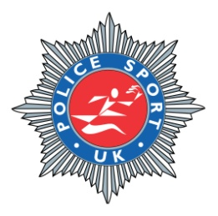
POLICE SPORT UK
TRACK AND FIELD CHAMPIONSHIPS
NORMAN GREEN ATHLETIC STADIUM
WEDNESDAY 6th JULY 2011
FORCE: -

FORENAME: -

SURNAME: -

SEX - AGE-

Principal event............................................. PB:- SB: - (£14) - £
(Packed lunch per person included in initial entry fee)

Additional event ......................................... PB:- SB: - (£4 per event) - £
Additional event.......................................... PB:- SB: - (£4 per event) - £
Additional event.......................................... PB:- SB: - (£4 per event) - £
Additional event.......................................... PB:- SB: - (£4 per event) - £
Additional event.......................................... PB:- SB: - (£4 per event) - £

Championship meal and function (£30 per person) - £
Special dietary requirements ..................................................................................
.................................................................................................................................

The following team events need only be entered once on the Team Captain’s
Individual entry form.
Please note Captain’s contact details here:............................................................

Ladies 4 x 100 Relay (£15 per team) - £
Gents’ Medley Relay (£15 per team) - £

We will require transportation from Birmingham International Airport: - Yes/No
Number of competitors requiring transportation: -.................................
We will require return transportation from St Johns Hotel to the Evening Function: - Yes/No
Number of competitors requiring transportation: -.................................

Total - £______

The closing date for entries is Friday 25th May 2011. No late entries will be accepted. No entries on the day and no refunds for non attendance.

Team Captains should return the entry forms to the following address:
West Midlands Police Sports & Social Club
Pershore Road
Edgbaston
Birmingham
B5 7RN

Cheques should be made payable to ‘WMPSSC’.
Alternatively payment can be taken by Bank Transfer, please contact the Club on 0121 626 8336

Any further information can be obtained from this address or by e-mail richard.cupper@westmidspoliceclub.com

Team Captains please note that the rules applicable to PSUK events are adhered to by all participating members of their Team. Force Colours must be worn by all competitors.

Events for competition at the Championships

TRACK MEN AND WOMEN
100, 200, 400, 800, 1500, 5000 metres

TRACK MEN
110 hurdles, 400 hurdles, 3000 steeplechase, 3000 walk.

TRACK TEAM
Ladies 4 x 100 Relay, Gents Medley Relay (800, 200, 200, 400)

FIELD MEN AND WOMEN
Shot, discus, hammer, long jump, high jump, triple jump, pole vault (starting height 2m 10cm) and javelin.

