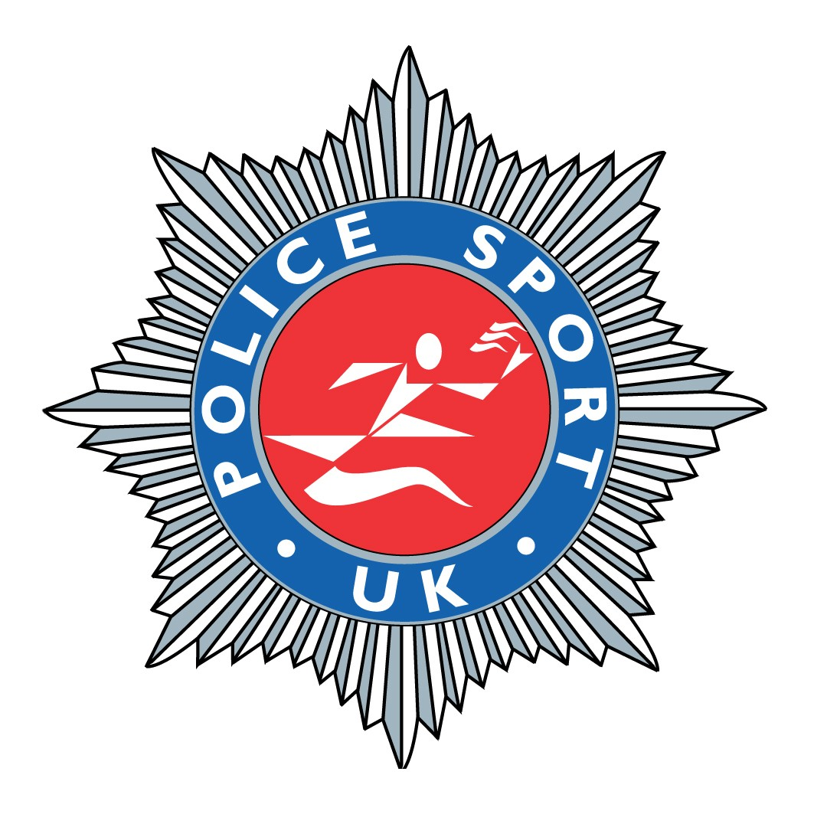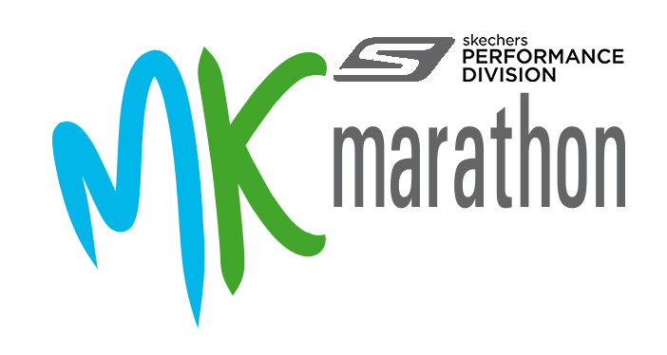
Police Sport UK Marathon
Entry form
Milton Keynes Marathon
10AM on Monday 5th May 2014

Force: …………………………………………………………Running Club:………………………………………………..

Name: Title …….…….. First Name …………………….…..……. Last Name ………………………..….………..

Police Title/Post: ……………………………………………….………………………………………………..………………….

Home Address: …………………………………………………………………………….…………..………………………………………..

…………………………………………………………………………………..……… Post Code: ……………………….………….

Date of Birth: / / Age on Race Day: …………….. Gender: M/F Telephone: Mobile …………………

Emergency Contact Name & No. ……………………………..………….…..

Home Email: …………………………………………………..@....................................................................

Work Email: …………………………………………………..@....................................................................

Predicted Time: …………..………………

Payments: Tick Tick

Milton Keynes Marathon Entry: £30.00 or already entered direct
Police Sport UK Championship Entry: £10.00 NB: £10 cost includes post race light buffet meal

Total Payment: £10.00 or £40.00

NB: The combined entry fee for the two Championships is £40.00. However, if you have already entered the Milton Keynes Marathon directly then simply send a payment for the PSUK Championships only.

Additional presentation meal tickets for guests £5.00. I require ……….. extra meals total £ ………

Please make all cheques payable to: “Hampshire Constabulary Athletics Section”.
Return to: Police Sport UK Marathon, Insp Katherine Willoughby, Hythe Police Station, Jones Lane, Hythe, Hampshire SO45 6DG. (Closing date 01/04/2014)
E-Mail: Katherine.willoughby@hampshire.pnn.police.uk Telephone Contact: 07818 073300
Disclaimer: I confirm that I am eligible to compete as defined by Police Sport UK rules and that I compete at my own risk.
I agree to the above disclaimer.

Signed: …………………………………………………………………………….…. Date: ……………………….…………………………..

Closing date for entries for PSUK Marathon Championships: 1st April 2014 – NO LATE ENTRIES WILL BE ACCEPTED…

Milton Keynes Marathon information go to: www.mkmarathon.com/mk-marathon/

