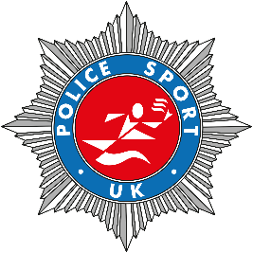
Police Athletic Section

We are pleased to announce that this year the PSUK Marathon Championships will take place within the Yorkshire Marathon in York on 15th October 2023. Details of how to enter will be supplied soon. PSUK will be provided with a bespoke entry code so please do not enter directly at his stage. For details of the marathon please follow this link: https://www.runforall.com/events/marathon/yorkshire-marathon/
Further details of how to enter will be sent out as soon as details have been finalised with the host. If you have any immediate questions please email: kwpsukas@btinternet.com

