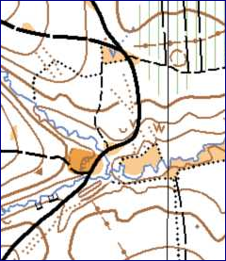
The 2014 PSUK Orienteering Championships will be held Breakneck Bank, Bewdley, Worcestershire on Sunday 27 April 2014 , within an event organised by the Harlequins Orienteering Club.
Breakneck Bank is an undulating forest with a good network of paths and rides and plenty of contour detail to challenge the more experienced orienteer.
There will be beginners’ courses if other family members want to also take part as well as the more technical courses. These can be entered on the day.
There will not be a presentation meal, but we will all meet for a picnic afterwards to encourage families to come along. There will probably be a caterer at the event selling hot food and drinks.
Courses
Course | Class |  | Distances - Approximately
A | Men’s Open | Blue colour standard | 6 -7 km
B | Women’s Open | Green colour standard | 4 -5 km
C | Veteran Men | Green colour standard | 4 -5 km
D | Veteran Women | Short Green colour standard | 3 -4 km
E | Introductory | Orange Standard | 3km

Notes

A veteran is aged 40 years or over on 1st January 2014.
The Introductory course will give a fit runner a good 40 minute run.
Pairs from the same Force may compete competitively on the Introductory course.
There will separate prizes for men and women on the Introductory Course.
Extra prizes will be awarded on Course C & D for competitors aged 55 years or older on 1.1.2014.
Start times: 10.30am – 12.30pm
Entry Fee: £8 per person SI Hire £1
Cheques payable to: PSUK Orienteering.

Entries
Please return your completed entry form and payment to Peter Guillaume, 25, Crimicar Drive, Sheffield S10 4EF by 14 April 2014.
Final details will be sent out by email and displayed on this web page: www.pgopage.co.uk/psuko.htm
Enquiries
Please contact Peter Guillaume by email: p.m.g@btinternet.com or telephone 0114 229 5919

