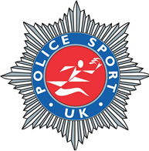
Track & Field Championships 2022

Hosted by Police Sport UK

Wednesday 10th August 2022

Avenue Rd, Nuneaton CV11 4LX
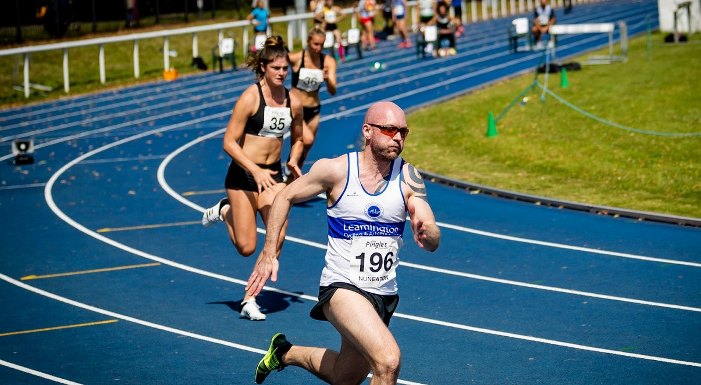

Welcome to your competition information for the PSUK Track and Field Championships 2022.
Once again we have teamed up with the Civil Service Athletic Association (CSAA) to hold a combined event.

The Championships themselves will be run separately from the CSAA championships, but the track, officials and atmosphere will be shared.

Travel:
Nuneaton is a small town in Warwickshire near to the borders with Leicestershire, Staffordshire and the West Midlands.
The Pingles Stadium has recently been refurbished and hosts many track events including the Night of the PBs series.
There is free parking at the stadium in the leisure centre car park for 3 hours or £2.50 for events.
There is also Electric Vehicle charging available. (Cost not known).
Accommodation
Options for accommodation are below:
Holiday Inn - St David's Way, Bermuda Park, Nuneaton CV10 7SD

Others:
Travelodge - A444 Southbound Bedworth, Nuneaton CV10 7TF
Travelodge - The Yeoman Harvester, St. Nicolas Park Drive, Nuneaton CV11 6EN
Premier Inn - Coventry Road, Nuneaton CV10 7PJ

Awards, medals and mementos: The usual annual Police Sport UK trophies will be presented at the trackside following the completion of each event. Gold, silver and bronze medals will also be awarded.
Event Dinner: TBC
Entries and Payments: Race entry forms are attached to the email and will also be available online at Championship Events - Team Police
Entry Cost: The cost of entries will be as follows - £15 for the first event and £3 for each additional event.
Payments should be made by Bank Transfer to: Stephen Gill (Barclays Bank) Sort Code 20-17-92 Account Number. 33069028
Attached to the Event Information is a team registration form. Please complete and return to Wendy at: wendy.gilham@kent.police.uk by the closing date. Please use the drop downs provided on the form. Forms will only be accepted through your TEAM CAPTAINS. Seek advice from your sports and social club. Events should be marked with an “x” in the correct box.
Contestants: Please make every effort to encourage members to participate from your force, in particular, new and younger members of staff who may be unaware of these championships. Also consider publicity in force magazines and other publications in the coming weeks.
Social Media There is a Facebook page set up – “PSUK Track and Field Champs”. Please feel free to check it out, I have used it to bounce ideas around and keep people up to date. It would be great to fill it with people’s pictures of their preparations and thoughts!!
Closing date – Entries close at 2300hrs on the 28th July 2021
Final instructions: Will be sent by email periodically leading up to the event.
Challenge Trophies: These must be returned engraved, in a clean and polished condition to the competition on the day.
Internet website: You may visit the Police Sport UK Track & Field Official website to access further information, results, updates, final instructions and post event results - www.policesport.org. Entry forms will also be obtainable form this site address.
Finally: I am looking forward to receiving your entries and am confident that the 2022 event will be most enjoyable and memorable for you and your members.
Yours in sport,
Greg Richards 07791 832 781
West Midlands Police Athletic Section
e.richards@west-midlands.pnn.police.uk
The timetable will be posted close to the event as we wait for numbers to come in. We will post on Facebook and the website to keep you informed.

Events to be contested

Track - Men and Women  - 100 metres  - 200 metres  - 400 metres  - 800 metres  - 1500 metres  - 5000 metres (Senior and *Vets)  - Relay – Ladies 4 x 100 metres  - Relay – Men’s Medley  - 3000m walk  Track - Men Only  - 100m *Vets (non-championship)  - 110 metres hurdles  - 400 metres hurdles  - 3000 metres steeplechase  Track Women Only  - 100m hurdles | Field - Men and Women  - Shot  - Discus  - Hammer  - Long jump  - High jump  - Pole Vault  - Javelin  - Triple jump  *Vets = Veterans - age 35+

