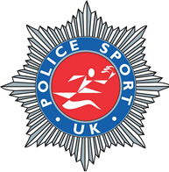
Track & Field Championships 2023

Hosted by Police Sport UK, Track and Field Committee

Wednesday 7th June 2023

The Pingles Stadium
Avenue Rd, Nuneaton CV11 4LX
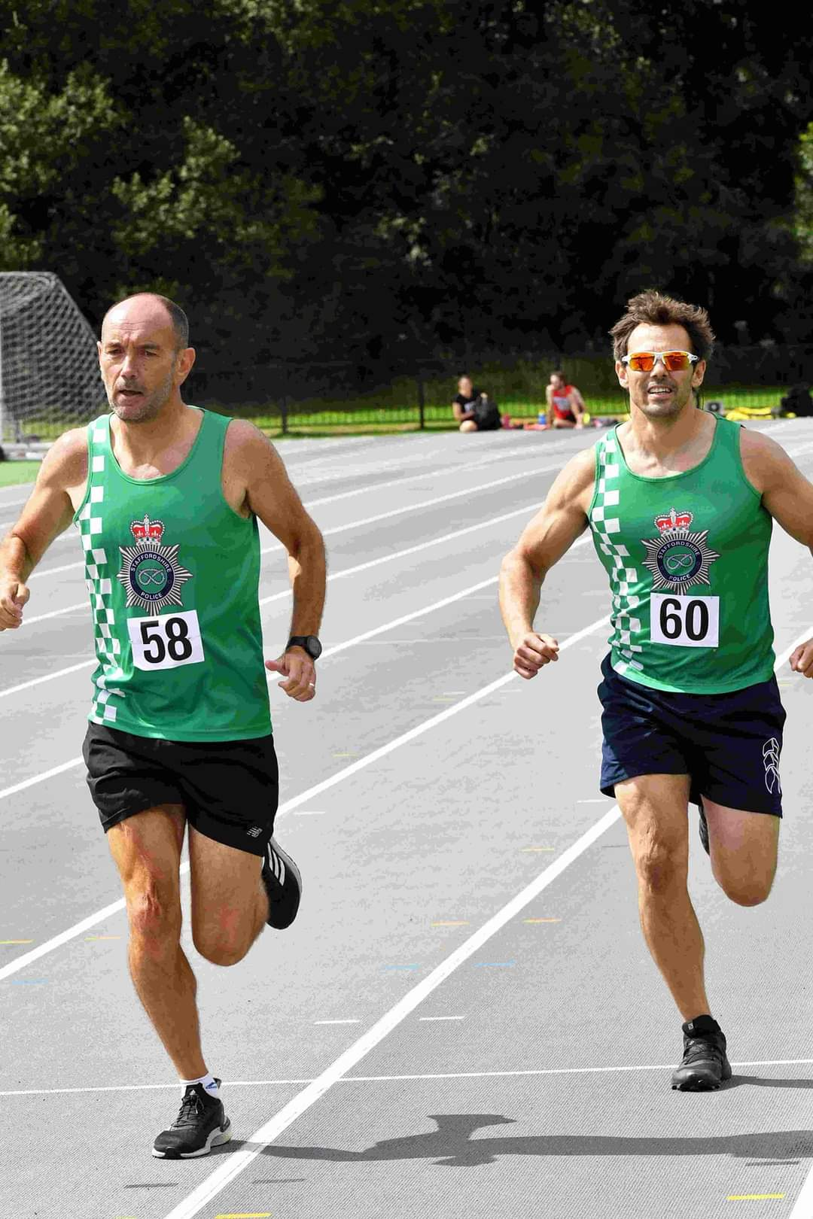

Welcome to your competition information for the PSUK Track and Field Championships 2023.

This year is a slightly different format than the last four as we have had to move the event forward, with the World Police and Fire Games taking place in July and the long-awaited USPE (European Police Sport) championships taking place in Prague in August. The European championships are a PSUK selection only competition, and selection will be drawn from these National Championships. More detail on the selection criteria will follow soon.

Due to bringing forward the competition, the Civil Service were unable to partner with us this year so we’re going it alone again. Your support is valued in making this a great day out.

Travel:
Nuneaton is a small town in Warwickshire near to the borders with Leicestershire, Staffordshire and the West Midlands.
The Pingles Stadium has recently been refurbished and hosts many track events including the Night of the PBs series.
There is free parking at the stadium in the leisure centre car park for 3 hours or £2.50 for events.
There is also Electric Vehicle charging available. (Cost not known).
Accommodation
Options for accommodation are below:
Holiday Inn - St David's Way, Bermuda Park, Nuneaton CV10 7SD

Others:
Travelodge - A444 Southbound Bedworth, Nuneaton CV10 7TF
Travelodge - The Yeoman Harvester, St. Nicolas Park Drive, Nuneaton CV11 6EN
Premier Inn - Coventry Road, Nuneaton CV10 7PJ

Awards, medals and mementos: The usual annual Police Sport UK trophies will be presented at the trackside following the completion of each event. Gold, silver and bronze medals will also be awarded.
Event Dinner: TBC
Entries and Payments: Race entry forms are attached to the email and will also be available online at Championship Events - Team Police
Entry Cost: The cost of entries will be as follows - £20 for the first event and £3 for each additional event.
Payments should be made by Bank Transfer to: Stephen Gill (Barclays Bank) using your name and Force as the reference Sort Code 20-17-92 Account Number. 33069028

Attached to the Event Information is a team registration form. Please complete and return to Wendy at: wendy.gilham@kent.police.uk by the closing date. Please use the drop downs provided on the form. Forms will only be accepted through your TEAM CAPTAINS. Seek advice from your sports and social club. Events should be marked with an “x” in the correct box.
Contestants: Please make every effort to encourage members to participate from your force, in particular, new and younger members of staff who may be unaware of these championships. Also consider publicity in force magazines and other publications in the coming weeks.
Social Media There is a Facebook page set up – “PSUK Track and Field Champs”. Please feel free to check it out, I have used it to bounce ideas around and keep people up to date. It would be great to fill it with people’s pictures of their preparations and thoughts!!
Closing date – Entries close at 2300hrs on the 24th May 2023
Final instructions: Will be sent by email periodically leading up to the event.
Challenge Trophies: These must be returned engraved, in a clean and polished condition to the competition on the day.
Internet website: You may visit the Police Sport UK Track & Field Official website to access further information, results, updates, final instructions and post event results - www.policesport.org. Entry forms will also be obtainable form this site address.
Finally: I am looking forward to receiving your entries and am confident that the 2023 event will be most enjoyable and memorable for you and your members.
Yours in sport,
Steve Gill, stephengill79@hotmail.com

Track and Field Committee

This is a provisional Timetable, however we do not anticipate it varying very muc.
The confirmed timetable will be circulated when the entries close.

PSUK Championships
Event time | Event (track) | Event time | Event (field)
11:00 | 400m hurdles Men | 10:30 | Hammer Men/Woman
11:10 | 1500m Men | 11:00 | Pole Vault Men/Woman
11:15 | 1500m Women | 11:15 | Javelin Women
11:30 | 100m Vet Men | 11:30 | High Jump Men/Woman
11:35 | 100m Men
11:40 | 100m Woman
11:50 | 100m
11:55
12:05 | 3000m Walk – CSAA/PSUK  Men & Women | 12:00 | Long Men/Women
12:35 | 3000m Steeplechase CSAA/PSUK Men | 12.30 | Discus Men
12:55 | 400m Men | 13:00
13:00 | 400m Women | 13:00 | Shot Women
13:05
 | ****** Lunch Break Track ******
13:45 | 110m Hurdles PSUK | 14:00 | Triple Jump Men/Woman
13:50
13:55 | 800m Women
14:05 | 800m Men | 14:00 | Shot Men
14:10 |  | 14:15
14:15 | 200m PSUK Men
14:30 | 200m Women
14:40
14:45 | 5000m Men/ Masters | 14:45 | Discus Women
14:50
15:15 | 5000m Women | 15:15 | Javelin Men
15:35 |  | 15:45
16:10 | 4 x 100m PSUK Women’s Relay
16:20 | PSUK Medley Relay
16:30

16TH USPE TRACK & FIELD CHAMPIONSHIPS
PRAGUE 28TH TO 31ST AUGUST 2023.

Dear all
This will be the first time since the Ukraine in 2010 that the Championships have been held.
The event will have a limited number of events:
Men: 100m, 400m, 1500m, 5000m. High Jump, Shot, Discus and Javelin
Woman: 100m, 400m, 800m, 3000m. High Jump, Shot and Javelin.

Under PSUK Rules we are allowed to take 28 athletes as well as up to 3 officials.
I do not foresee us selecting anywhere that number.
We do need to consider Selection criteria which needs to be done as soon as we can to give athletes the time to be aware.
The PSUK Track and Field Championships are to be held in Nuneaton on Wednesday 7th June and this week needs to be the cut off for selecting the team.
Anyone wishing to be considered should submit performance results from the past 6 months to Steve Gill – stephengill79@hotmail.com

Track - Men and Women  - 100 metres  - 200 metres  - 400 metres  - 800 metres  - 1500 metres  - 5000 metres (Senior and *Vets)  - Relay – Ladies 4 x 100 metres  - Relay – Men’s Medley  - 3000m walk  Track - Men Only  - 100m *Vets (non-championship)  - 110 metres hurdles  - 400 metres hurdles  - 3000 metres steeplechase  Track Women Only  - 100m hurdles | Field - Men and Women  - Shot  - Discus  - Hammer  - Long jump  - High jump  - Pole Vault  - Javelin  - Triple jump  *Vets = Veterans - age 35+

