Wiltshire Police look forward to Welcoming you to PSUK 2023 Cross Country Championships.

The 2023 Cross Country Championships will take place on Wednesday 15th March and held in the beautiful area of the Cotswolds Water Park in North Wiltshire. The race itself will be held on a route circling one of the many lakes in the area and is less than half a mile from the location of the evening function and accommodation. The particular lake has recently been used for the filming of George Clooney’s new film – “The boys in the boat” (George Clooney film set in Wiltshire revealed in new pictures | Swindon Advertiser)

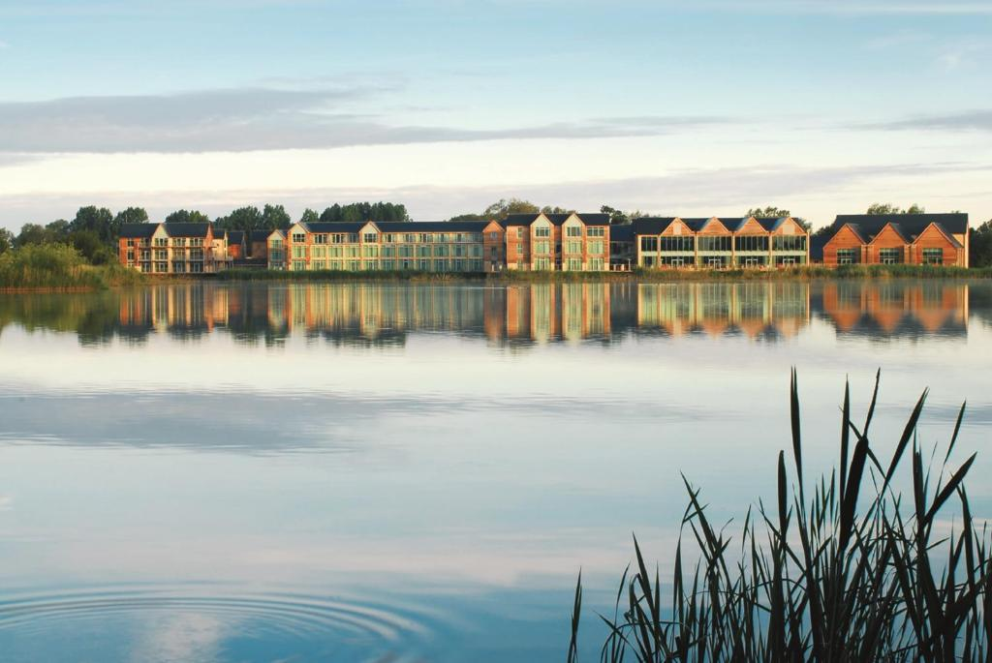

RACE COST/ENTRY
Individuals will need to enter via the following link - https://endurancecui.active.com/event-reg/select-race?e=82882632 - race entry is £20 PP.

RACE VENUE
Cleveland Lakes Nature Reserve
(Via Cleveland Farm Quarry Entrance)
Fridays Ham Lane
Ashton Keynes
SN6 6QW
What3Words: /// ship.weeded.strapping

The entrance to the Quarry will be signposted and Marshalled.

PARKING
There is plenty of free parking on site and you will be able to gain entry from 10:15 please adhere to the 10mph speed restrictions and follow the Marshal instructions for parking on entry.
TOILETS
There are portaloo toilets on site but no changing rooms, however the hotel post finish is only 5 mins away.
COURSE
The Course is an approximate 2 mile loop around the Cleveland lakes permissive path following a clockwise trail, the course is flat (I promise ) and runs through the nature reserve, whilst the route will be checked and made as safe as possible it is a trail/cross country run therefore may be subject to debris, uneven ground and slippery when wet. The route can be seen here - Cotswold Water Park 10k run route – Google My Maps.
Please note due to the location being amongst trees and near a large body of water this can distort some GPS readings.
There is a section of the course which involves the crossing of a small wooden bridge, this is currently having some construction work conducted, the route will either be over or around the bridge depending how that work goes and the weather on the day, as a result we wont know until the morning of the race how this section will look, it will be marshalled and also announced during the pre race safety briefing, it is therefore important that everyone attends that briefing.

REGISTRATION
Registration will be situated near the finish which is only a short walk from the car park. Registration will be open from 10:45.
Please can we ask individuals to collect their own bib and timing chip, this ensures that everybody gets the right timing chip/finish times to ensure accuracy of results.

RACE DETAILS
Ladies Race Start Time – 12:45
Mens Race Start Time – 13:30
The mens race will start upon conclusion of the ladies race (13:30 is an approximate time however only put in place as a guide
The start line is only a short 5 minute jog from the registration area.

BAG STORAGE
There is no planned bag storage area, runners are welcome to leave items near the registration tent and although footfall is low this will be at your own risk, however the car park is so close to the race start that its recommended that valuables are left in vehicles where possible.

FIRST AID
First aid provisions will be available on the day should it be required and there will be marshalls on the course with radio contact back to the organisers should you encounter any difficulties mid race.
PHOTOGRAPHY
Photography will take place on the course by a local photography with images uploaded to a central internet for downloading, spectators are welcome to take photos also and upload to the facebook page for sharing.
RESULTS
The race will be chip timed and available post event – a link will be circulated post event.

PRESENTATIONS
Presentations of awards will be made during the evening function, category trophies will be given out along with the PSUK trophies, if you are in possession of one of the PSUK trophies from Humberside please bring these with you.

Evening Function
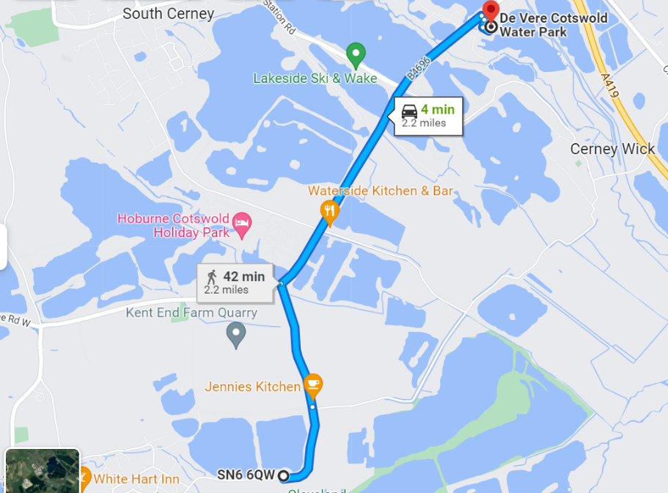
The address for the evening function is – De Vere Hotel, Cotswolds water Park, Lake, 6 Spine Rd East, Cirencester GL7 5FP (4 minute drive from the race)

Food will consist of a sit down 3 course meal which will start at 18:00 hours allowing time for food and presentations before the evening fun. To take away the pressure of a formal black tie affair the dress code this year is “FANCY DRESS” – This is not a joke, it is genuinely fancy dress 😊 Each team are to decide on their own theme with spot prizes awarded on the night for the best themes as well as individual prizes being awarded.
Food will be followed by a live band who will start at 20:00 through to 23:00 with additional music running through to midnight, the bar will remain open until 01:00 for those attending and later for guests staying at the hotel.

FOOD BOOKINGS
Attached to this form you will find a food/evening booking form – please can I ask team managers to fill this in and return to stuart.welch@wiltshire.police.uk - the form contains details of where the payment needs to be made to. Forms and payments are required by the deadline of the 15th February 2022.

ACCOMODATION
There is a gym/spa on site with pool, sauna and Jacuzzi should you choose to stay at the same venue and find time to make use of the facilities – a negotiated room rate has been set up as follows, spa access is at a negotiated rate of £10 which needs to be pre booked.
B&B rate is £169 single occupancy and a double occupancy is £179 per room sharing, please phone the hotel direct on 01285 864000 and quote – WILT150323 – Rooms at this price are limited to £50 after which they raise to their normal price (approx £15 more) so please book early.

There are holiday parks close by that may offer alternative accommodation and hotels within taxi/driving distance – the hotel can pre book taxis should you wish to stay elsewhere – its appreciated that the cost of accommodation is not cheap however with general costs rising so have hotel prices and what you may pay extra in accommodation you could save in taxi fares and ease of staying on site.

On behalf of Wiltshire Police we look forward to hosting this event and seeing you all in March.

Stuart Welch

